Relational Databases with MySQL Week 4 Coding Assignment

**Points possible:** 70

|  |  |  |
| --- | --- | --- |
| Category | Criteria | % of Grade |
| Functionality | Does the code work? | 25 |
| Organization | Is the code clean and organized? Proper use of white space, syntax, and consistency are utilized. Names and comments are concise and clear. | 25 |
| Creativity | Student solved the problems presented in the assignment using creativity and out of the box thinking. | 25 |
| Completeness | All requirements of the assignment are complete. | 25 |

**Instructions:** Using a text editor of your choice, write the queries that accomplishes the objectives listed below. Take screenshots of the queries and results and paste them in this document where instructed below. Create a new repository on GitHub for this week’s assignments and push this document, with your Java project code, to the repository. Add the URL for this week’s repository to this document where instructed and submit this document to your instructor when complete.

**Coding Steps:**

Write 5 stored procedures for the employees database.

Write a description of what each stored procedure does and how to use it.

Procedures should use constructs you learned about from your research assignment and be more than just queries.

**Screenshots:**

1. **This procedure takes an input of the first few letters of a last name and then prints out everyone at the company whose name is similar and shows their average salary for the time they worked there along with their current age.**

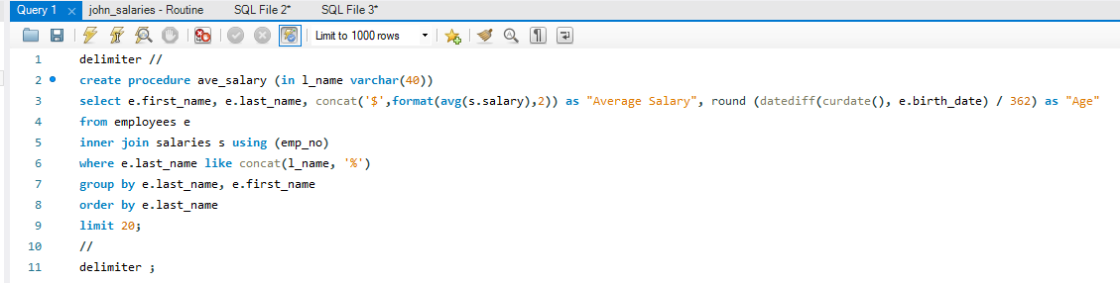

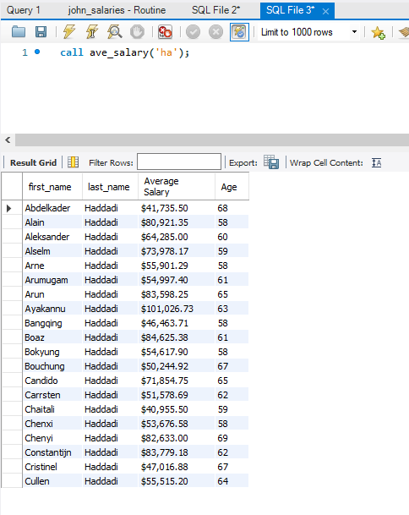

1. **This procedure takes in the name of the department and returns the number of men verses the number of women in that department. It allows you to enter a partial department name and then matches it.**

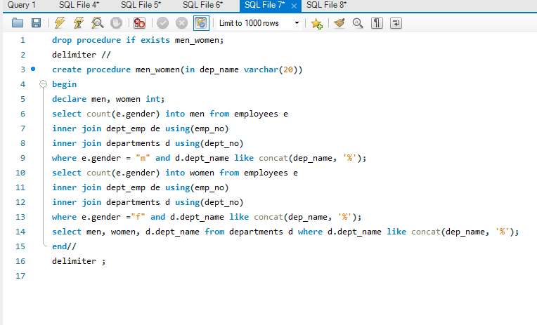

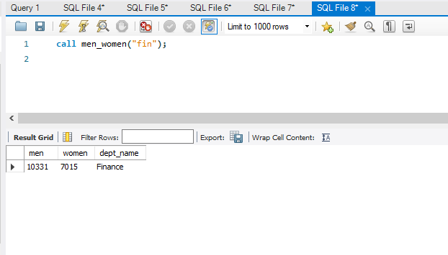

1. **This procedure takes in the employee number and finds the current salary for that employee then returns a statement on whether the employee is a “High level, Middle Level, or Low Level” employee based on the employees salary.**

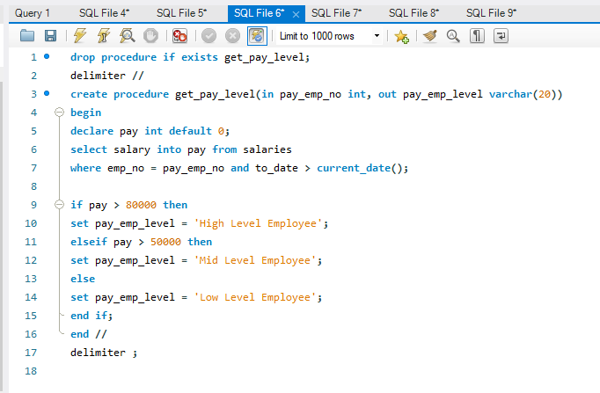

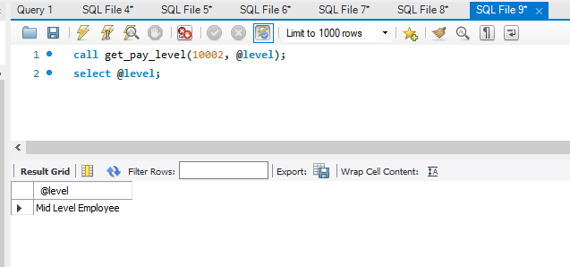

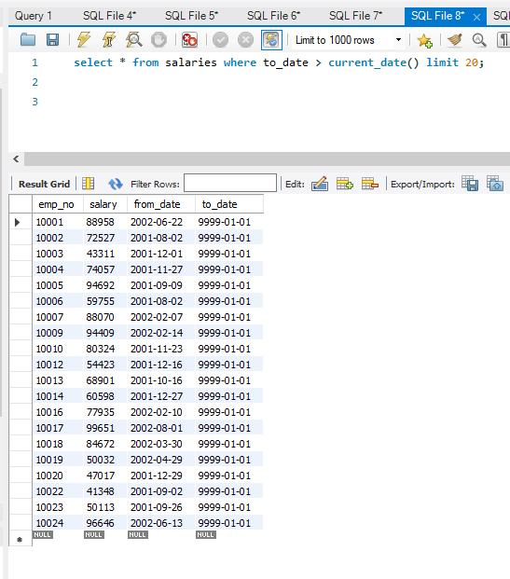

1. **This is a complicated procedure that can be used in a loop in other procedures to insert new salaries into the database. The input is the department number and the number of an employee who works in that department. It returns the employees employee number, the salary and a check to see if it is the last employee in the department (returns 1 if it hasn’t reached the last employee and returns a 0 if it has reached the number of employees in the department).**

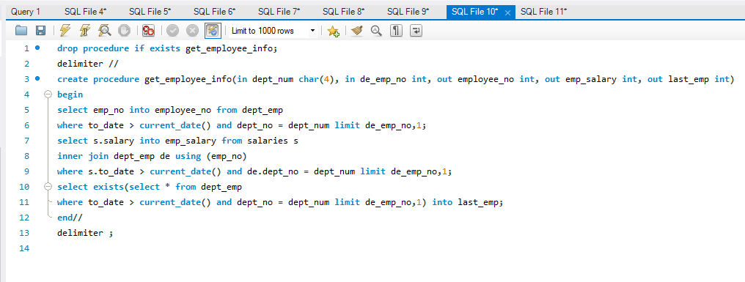

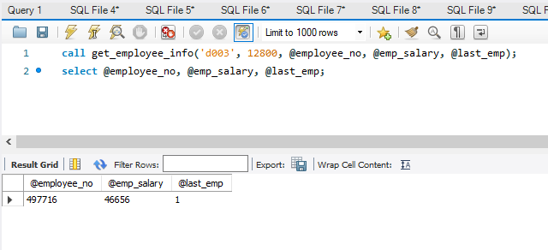

**5)This procedure will give a fixed raise amount to all current employees in a given department. The input is the department number and the raise amount.**

**It sets the end date for all of the employees current salary to the current date. Then it calls the get_employee_info procedure inside a while loop to increment through all of the current employees in the department and inserts a new salary record for each employee with the current date as the starting date and adds the raise amount to their current salary to give them a new salary.**

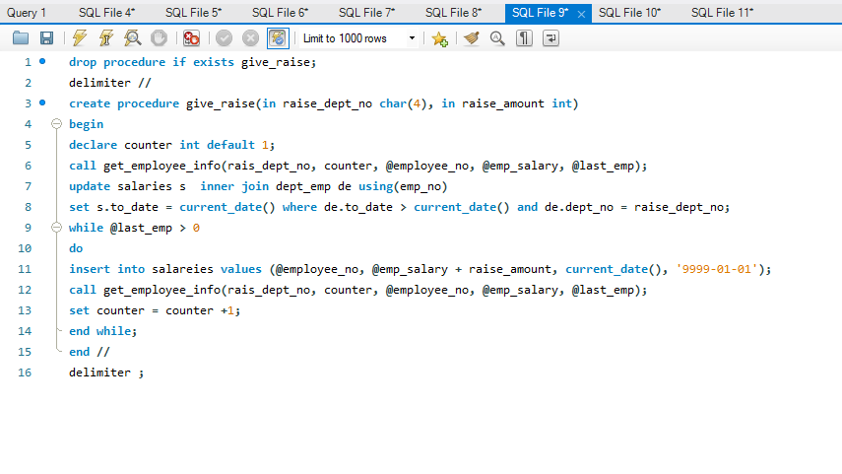

**URL to GitHub Repository:**

**https://github.com/jhancock55/week-4-mysql.git**